GRACE GROUPS POST SESSION SELF EVALUATION
This is a Grace Groups self-evaluation form. This is not to be turned in to your Grace Group Leader or Host, but is for your own information and to document your own spiritual, emotional and relational growth. Please fill out this self-evaluation form before attending a Grace Group Session and once after attending a Grace Groups Session and note your own personal growth. You may easily use this for more than one session, just by using different color pens or markers.

Which Grace Group were you in? When did you start? What was the date the group last met?

On a scale of one to ten where do you place yourself in terms of your spiritual, emotional and relational growth, speech, thought life, actions, caring, sharing, overall attitude, personal character, patience, Christ-centered motivation and desire, kindness and giving? Then give yourself a post Grace Groups Session score.
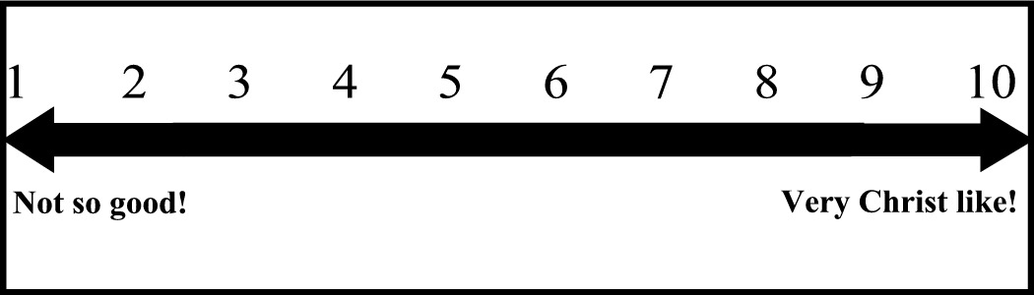
Answer these questions for your own information once before your Grace Groups Session and once after.

How does God see you?

How do you see God?

How do others see you?

How do you see others?

(When you need a new form, you can print one from the church’s Web site)
www.GraceFamilyAG.org/forms.htm

